STAT 200, Midterm Exam Due Sunday, September 22, 2019

NAME: Benjamin Bussie DATE: 9/22/19

I have completed this assignment myself, working independently and not consulting anyone except the instructor.

INSTRUCTIONS

- There are seven problems (on 6 pages) with multiple parts. On average, each part or subpart of Problem I (with a total worth of 27 points) is worth about 2 points, except for Part (5), which is worth about 8 points. Other problems are worth as indicated with almost equal number of points to be considered for each part of a problem. A grand total of 100 points for evaluation comprises 20% of your final course grade. This quiz is open book and open notes. This means that you may refer to your textbook, notes, and online classroom materials, but you must work independently and may not consult anyone (and confirm this with your submission [signing and dating above]). You may take as much time as you wish, provided you turn in your quiz no later than 11:59 PM (US Eastern Time Zone) Sunday, September 22, 2019.

- Show work/explanation. Answers without any work may earn little, if any, credit. You may type or write your work in your copy of the midterm exam, or, if you prefer, create a document containing your work. Scanned work is acceptable also; a single file in pdf format is preferred. In your document, please make sure that you include your name and the assertion of independence of work.

- If you have any question, please ask in class, post it in the “Ask the Professor” discussion on LEO, or contact me privately via e-mail (Amir.Mobasheran@faculty.umuc.edu).

Please read the problems/questions very carefully.

Problem I – [27 points] Write your first name, middle name, and last name in capital letters. The letters involved in your full name would comprise your data set. In case you do not have a middle name, or you do not want to include your real middle name, make one up. Then, do the following

- Write your data in order from A to Z and double check. For example, the student whose complete name is First Middle Last would have the following 15 ordered letters:
A D D E F I I L L M R S S T T

Your full name: BENJAMIN JOSEPH BUSSIE

Letters in order with existing repetitions:
A B B E E E H I I J J M N N O P S S S U

- Is your data set a sample or a population? Support your answer briefly.
My data set is a sample because it contains all of the elements from the alphabets.

- Considering your answer to the previous question, show the size of the data set under consideration using the appropriate symbol in statistics: n = … or N = 20

- What is (are) the mode(s) within your data set, if any?
The modes for my data set would be the letters E and S

Is your data set unimodal, bimodal, trimodal?
My data is bimodal

What is the frequency of the mode(s)?
The frequency of both modes in the data set is 3

- [≈ 8 points, out of the 27 points total for Problem I] Construct a complete, five-column “Frequency Distribution Table” for your data from Part (1) above. You should choose a descriptive title for your table and use the following headings for your table columns:

Letter, Frequency (F), Relative Frequency (RF), Cumulative Frequency (CF), Cumulative Relative Frequency (CRF).

Letter | Frequency | RF | CF | CRF
A | 1 | 0.05 | 0.05 | 0.05
B | 2 | 0.1 | 0.15 | 0.15
E | 3 | 0.15 | 0.30 | 0.30
H | 1 | 0.05 | 0.35 | 0.35
I | 2 | 0.1 | 0.45 | 0.45
J | 2 | 0.1 | 0.55 | 0.55
M | 1 | 0.05 | 0.60 | 0.60
N | 1 | 0.05 | 0.65 | 0.65
O | 1 | 0.05 | 0.70 | 0.70
P | 1 | 0.05 | 0.75 | 0.75
S | 3 | 0.15 | 0.90 | 0.90
U | 1 | 0.05 | 0.95 | 0.95

While populating the table, whenever a numerical value is not a whole number, present the value in decimal format with two decimal places, after rounding the value correctly. Please check your table to make sure that the values are correct. The total under F should be the data set size. Depending on the extent of round-off error(s), the total under RF should be 1, or very close to 1. The last value under CF should be the data set size. Depending on the extent of round-off error(s), the last value under CRF should be 1 or very close to 1.

- Using the frequency distribution table created in the previous part, and, preferably, hand drawing on (graph) paper (show work, in case you use technology),

- Construct a “bar chart,” with a descriptive title for it and descriptive labels for its horizontal and vertical axes, for the F distribution; a Pareto bar chart is preferred, which means displaying the categories (your letters) from the highest F to the lowest F from left to right.

- Construct an “ogive,” with a descriptive title it and descriptive labels for its horizontal and vertical axes, for your CRF distribution, using the same order of letters used in your bar chart.

- Not required to draw a pie chart here, what would be (in percentage) the share of your mode(s) from the pie? Briefly explain your answer.

The mode percentage for E is 15% and the mode percentage for S 15% of the data set.

Problem II – [18 points] Choose and write down a sample of 12 distinct (different) positive integers (no modes), each less than 100, in a way that your data set would have a range of 90, a mean of 59, and a median of 55

- In order not to treat the data as an abstract set, state what your data might represent with an applicable unit.
8 | 40 | 48 | 52 | 53 | 54 | 56 | 70 | 71 | 74 | 84 | 98

- Show your data set and your work to demonstrate that your data set does have the statistical characteristics mentioned. Consider your data set as a sample.
Range 98-8= 90
Mean = 708/ 12
= 59
Median = (54 +56) / 2
= 55
Sample size = 12
- Estimate the standard deviation using the “range rule of thumb,” which is based on the fact that four standard deviations practically cover the span of the data (about 95% for normal distributions), when rank ordered. Do not calculate the actual standard deviation value using its formula or technology for this part. The standard deviation found would have the same unit as in Part (a) above; the unit should accompany the value when reported.
Solution
Range = 4 × s.d
90 = 4x
x = 90/ 4
standard deviation = 22.5
What would be an estimate for the variance? Do not forget its unit, if any.
Variance = 22.5²
= 506.25
- Use technology (for example, the “Variance and Standard Deviation Applet,” provided under
Content > Course Resources > Free Web Applets in LEO) to find the actual values (in two decimal places) for the variance (with its unit, if any) and the standard deviation (with its unit, if any) of your data set, considered as a sample.
count | 12
sample standard deviation | 23.04
sample variance | 530.73

If you mistakenly treated your sample as a population, what would be the impact of your mistake on calculated values for the variance and the standard deviation? Why? Briefly explain.
Solution
If the data is treated as a polulation the values for standard deviation and variance will be smaller than those calculated previously. This is because the quotient used in calculations for population parameters is 12 while that of sample parameters is 11.

- Provide the five-number summary.
Descriptive statistics
 | data
minimum | 8
1st quartile | 51.00
median | 55.00
3rd quartile | 71.75
maximum | 98

- Determine the Interquartile Range (IQR).
IQR = 71.75 – 51
= 20.75
- Using your “actual value” for the standard deviation (STD) from Part (d) above, determine what percentage of the data points would fall within one STD of the mean, i.e., within the interval (mean – STD, mean + STD). Compare your answer with the Empirical Rule percentage. Briefly explain the inconsistency, if any.
Solution
59 – 22.04 = 36.96
59 + 22.04 = 81.04
9 values fall within the range
= $\frac{9}{12}×100$
= 75%
The percentage is higher than that of empirical rule. According to empirical rule the percentage should be 68%.
Problem III – [9 points] Assuming that the 26 letters in the English language alphabet comprise a population,

- Briefly explain how a simple random sample of size n = 6 can be determined to contain unique letters.

In order to determine the simple random sample of size n=6 so that each letters are unique we use the principle of permutation and combination

- Showing your work, find the total number of simple random samples of size n = 6 possible (each sample containing unique letters).

The total number of ways of simple random samples of size n=6
=${26}_{c}$6
=$26*25*24**23*22*21÷6*5*4*3*2*1$
=$165765600/720$
=230230

- What is the probability of drawing a simple random sample of size n = 6 containing C, D, G, P, Q, and Z at first attempt, from a bag containing 26 ping pong balls, each uniquely labeled one of the 26 letters?
=( $\frac{1}{26})^6$
= 0.000
Problem IV – [6 points] Suppose that a pie chart for Problem I is used in the construction of a “wheel of fortune” (a pointer and a rotatable board (wheel) reflecting your pie chart). If the wheel is rotated freely and the pointer, after the wheel comes to rest, points to a letter that is your first initial, you win.

- What is the probability of winning?
2/20

- Find the odds against winning.
18/20

Problem V – [6 points] Considering the 36 possible ordered pairs of numbers (faces) when a pair of fair dice is rolled (as the data set in Example 4.2.7 or in Example 4.2 8 of the e-book that we study), answer the following two questions:

- Are the Event A, comprising outcomes with both values being even, and Event B, comprising outcomes with both values being odd, mutually exclusive events (disjoint events)? Briefly explain your answer.

The probability of both event a and event b occurs= 0 thus they are mutually exclusive events.

- Are the Events C = {(4, 1), (4, 2), (4, 3), (4, 4), (4, 5), (4, 6)} and D = {(1, 4), (2, 4), (3, 4), (4, 4), (5, 4), (6,4)} statistically independent? Use the “Multiplication Rule” for testing statistical independence that states: if the probability of the occurrence of the common outcome(s) between two events is equal to the product (multiplication) of probabilities of occurrence of the two events, those two events are statistically independent.

Problem VI – [12 points] A “fair,” “relatively thick” coin, when flipped, can show heads (H) or tails (T) with equal probabilities if it going to come to rest on one of its two faces, but it may decide to come to rest on its edge (E) with a probability of 6%. Showing your work, answer the following questions:

- Set up a probability distribution table for the three possible events.

Heads (H) | Tails (T) | Edge €
0.47 | 0.47 | 0.06

- If the coin were flipped twice, what would be the probability that it would show heads the first time and would sit on its edge the second time? Provide a brief explanation to support your computation(s). Show the probability value in 4 decimal places.
 | H | T | E
H | HH | TH | EH
T | HT | TT | ET
E | HE | TE | EE

Hence, we are looking for HE = 0.47 × 0.06
= 0.0282
- If the coin is flipped 12 times, what is the probability that the coin would sit on its edge (“getting edge”) at most once? Showing your work, report the probability value in 4 decimal places. Treat the problem as a binomial experiment.
SOLUTION
P(E ≤ 1) = P(E=0) + P(E=1)
= (1×1×0.4759) + (12×0.06×0.5063)
= 0.4759 + 0.3645
= 0.8404

- Determine the probability of getting tails between 3 to 10 times (both inclusive) when the coin is flipped 12 times. Showing your work, report the probability value in 4 decimal places. Treat the problem as a binomial experiment.
SOL
P(X= 3) = 0.0754
P(X = 10) = 0.0098
= 0.0656
- What is the probability of getting heads or tails at least once when the coin is flipped 12 times? Showing your work, report the probability value in 4 decimal places. Treat the problem as a binomial experiment.
SOLUTION
P(H ≥ 1) = 0.9995

Problem VII – [22 points] For this problem, you should show, or briefly explain, your work involving graph(s), shading, and appropriate probability distribution table(s)/formula(s)/applet(s). Show probability values to preferably four decimal places,

If the heights of women are normally distributed with a mean of 65.0 inches and a standard deviation of 2.5 inches and the heights of men are normally distributed with a mean of 69.0 inches and a standard deviation of 2.8 inches,

- Calculate and write down your height in inches.
My height = 74.8 inches

- Determine the probability of finding a person of your gender to be exactly at your height.
Soln
Since I’m a man I will use mean = 69 and standard deviation = 2.8 inches
z-score = $\frac{74.8-69}{2.8}$
= 2.07
Using two tailed test the p-value = 0.0384

- Determine what percentage of people of your gender would be taller than you are. In case your height is “exactly” 65 inches or 69 inches, add 1 inch to it and keep working with that new height for this part of the problem.
Solution
Since I’m a man I will use mean = 69 and standard deviation = 2.8 inches
z-score = $\frac{74.8-69}{2.8}$
= 2.07
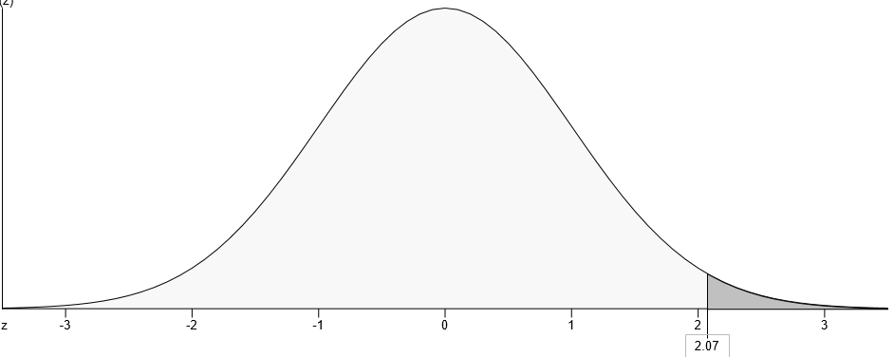
The probability = 0.192

- If someone of your gender were randomly selected, what would be the probability that the selected person would be shorter than you are?
Solution
Since I’m a man I will use mean = 69 and standard deviation = 2.8 inches
z-score = $\frac{74.8-69}{2.8}$
= 2.07
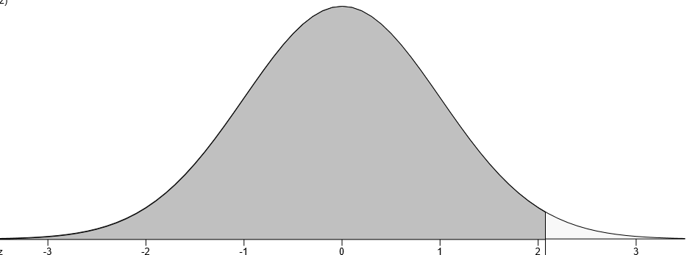
The probability = 0.9808

- What is the probability for the height of a person of your gender to be within 3 inches of your height (between “your height – 3 inches” and “your height + 3 inches”)?
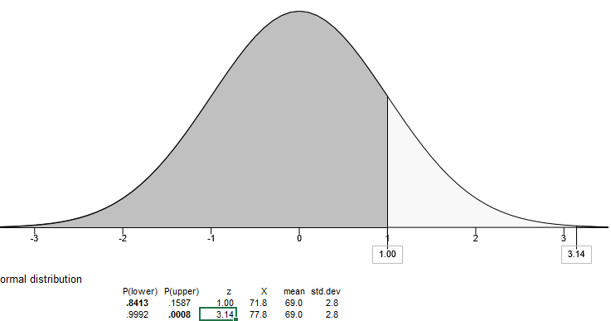

= 0.9992 – 0.8413
= 0.1579
- What is the minimum height of a person of your gender to be eligible for joining the “Top 15% Tall Club”?
Solution
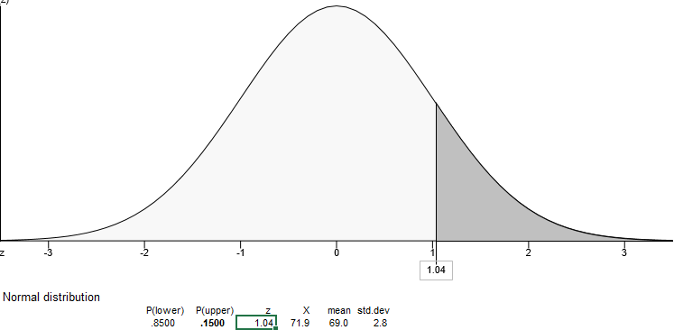
For one to be at the top 15% they should have a minimum height of 71.9 inches.
- If 49 people of your gender are randomly selected, determine the probability that their mean height would exceed your height.
Solution
Since I’m a man I will use mean = 69 and standard deviation = 2.8 inches
z-score = $\frac{74.8-69}{0.4}$
= 14.5
The probability is 0.000.

